**RESULTS:**

The following plots are for Reynolds number 400:

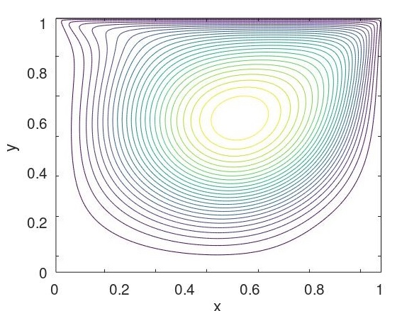

Contours of temperature for using MAC

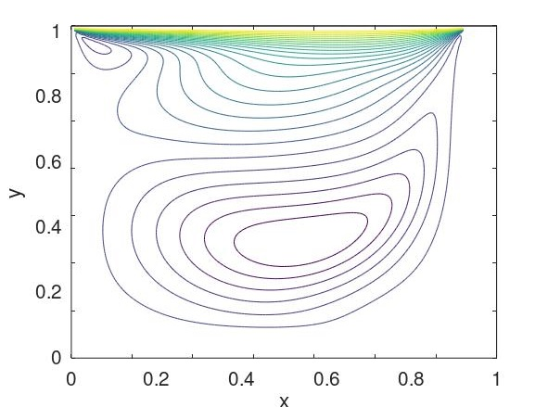

Contours of *u* velocity

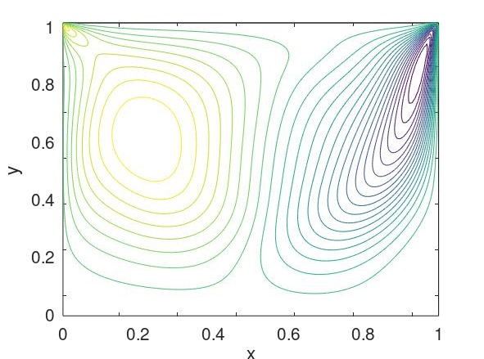

Contours of *v velocity*

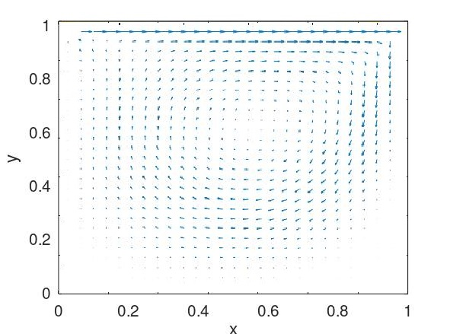

Vector plot of velocities

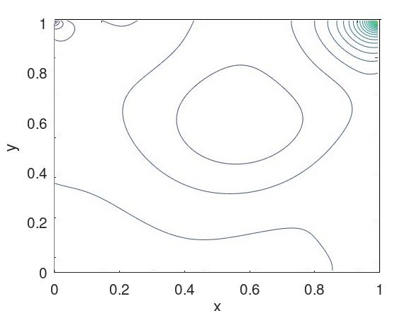

Contours of *pressure*

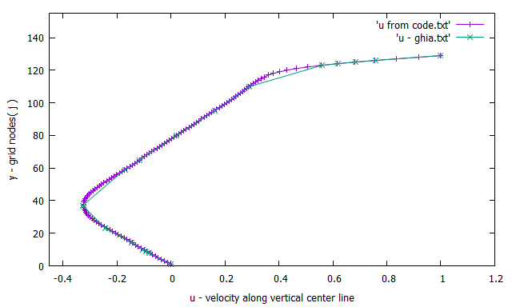

Comparison of *u* velocity profile along mid-vertical line with results from Ghia et al.

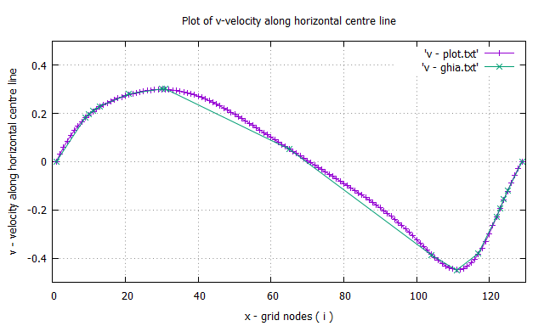

Comparison of *v* velocity profile along mid-horizontal line with results from Ghia et al.